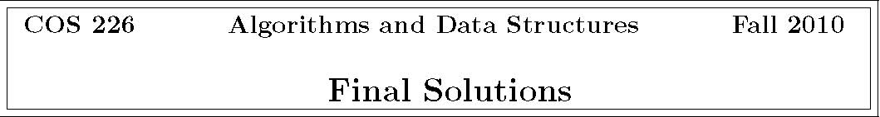
1. Analysis of algorithms.
U Find a maximum spanning tree in a connected edge-weighted graph.
This problem and the MST linear-time reduce to one another (by negating the weights). The existence of a deterministic linear-time algorithm for the MST is an open problem.
P Find all vertices reachable from a given set of source vertices in a digraph. We used this subroutine in the NFA simulation algorithm for regular expressions.
I Find a Hamilton path in a digraph (if one exists). This problem is NP-complete, so unless P = NP , it cannot be solved in polynomial time, let alone in linear time.
P Find a Hamilton path in a DAG (if one exists).
This can be found by computing the topological order and checking that there is an edge between each consecutive pair of vertices in the order.
P Find the strong components of a digraph.
Kosaraju’s or Tarjan’s algorithm does this.
P Insert N Comparable keys into a binary heap.
The sink-based heap construction method used in heapsort achieves this.
I Sort an array of N Comparable keys. This would violate the NlgN sorting lower bound because Comparable keys can be accessed only through the compareTo() method.
I Insert N Comparable keys into a binary search tree. This would violate the NlgN sorting lower bound because Comparable keys can be accessed only through the compareTo() method and an inorder traversal of the BST would yield the keys in sorted order.
P Compute the inverse Burrows-Wheeler transform.
You did this on Assignment 8.
P Insert N strings into an R-way trie.
Inserting each string takes time proportional to its length.
P The number of nodes in a TST is bounded by the the total number of characters.
P Perform a nearest-neighbor query in a 2-d tree.
You algorithm from Assignment 7 has this property (even though it’s running time is typically much better in practice).
2. Equivalence relations.
. v.equals(w) for objects in a Java class that correctly implements the equals() method
−−− v.compareTo(w) < 0 for objects in a Java class that correctly implements the Comparable interface
. connected(v, w) in CC for connectivity in an undirected graph
−−− reachable(v, w) in TransitiveClosure for reachability in a digraph
. stronglyConnected(v, w) in KosarajuSCC for strong connectivity in a digraph
3. Depth-ﬁrst search.
(a) preorder: ABGCDFEHI postorder: GBEIHFDCA
(b) I and II only
The function-call stack always contains a sequence of vertices on a directed path from s to the current vertex (with s at the bottom and the current vertex at the top).
4. Minimum spanning tree.
(a) 123467915
(b) 613247915

5. Shortest paths.
(a) v edgeTo[] distTo[] (b) v edgeTo[] distTo[]
0-0.0 0-0.0 1 2->1 33.0 34.0 1 2->1 33.0 34.0 2 0->2 1.0 1.0 2 0->2 1.0 1.0 3 2->3 11.0 12.0 3 2->3 11.0 12.0 4 5->4 33.0 53.0 4 *6->4 13.0 *52.0 5 3->5 8.0 20.0 5 3->5 8.0 20.0 6 1->6 5.0 39.0 6 1->6 5.0 39.0 7 5->7 46.0 66.0 7 *6->7 6.0 *45.0 8 -infinity 8 *6->8 10.0 *49.0
(c) 2 → 1, 0 → 2, 2 → 3, 7 → 4, 3 → 5, 1 → 6, 6 → 7, 6 → 8
6. Polar sort.
(a) Not a transitive relation, as required by the compareTo() contract. To see this, let p be (0, 0); let q1 be (1, 1); let q2 be (−1, 1); let q3 be (0, −1). Then, with respect to p, q2 is counterclockwise of q1; q3 is counterclockwise of q2; and q1 is counterclockwise of q3.
(b) When comparing two points q1 and q2 by the polar angle they make with p, ﬁrst compare the y-coordinates of q1 and q2 to that of p. If one has a bigger y-coordinate than p and the other has a smaller y-coordinate than p, then the one with the smaller y-coordinate makes a greater polar angle with p; otherwise if both have bigger or both have smaller y-coordinates, then the ccw-based code works. (A special case is needed to handle the case when q1 and q2 have the same y-coordinate as p.)

7. Kd-trees.
(a) 1 2 3 6 8 9 (though the search may go one extra level, depending on implementation)
(b)

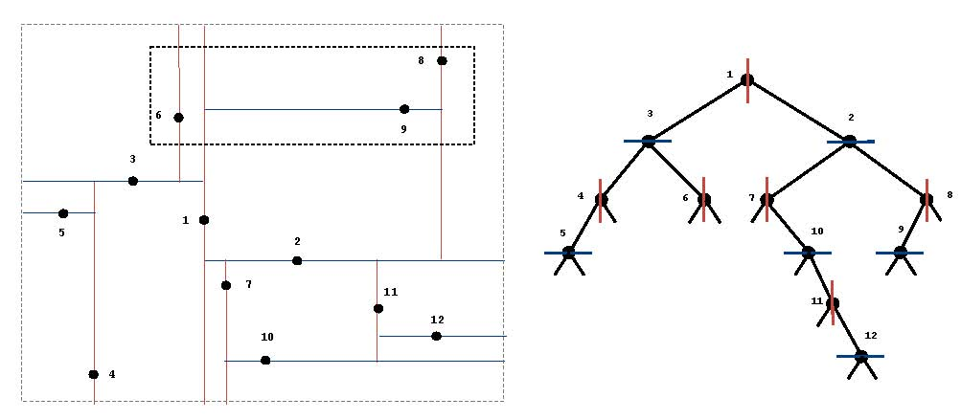
8. Substring search.
9. Regular expressions.
10. Substring search and pattern matching.

0 |  | 1 | 2 | 3 | 4 | 5 | 6
a | 1 | 1 | 1 | 4 | 1 | 6 | 1
b | 0 | 2 | 0 | 0 | 5 | 0 | 2
c | 0 | 0 | 3 | 0 | 0 | 3 | 7

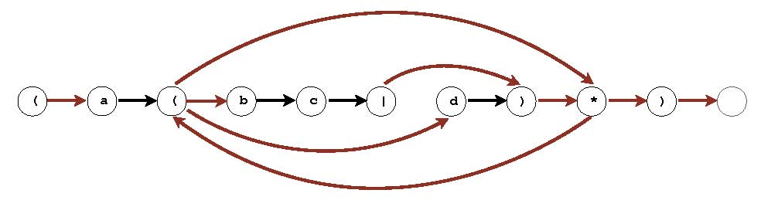
E brute-force substring search A. M C/D Knuth-Morris Pratt B. N/M E Boyer-Moore (with only mismatch heuristic) C. N
C/D Monte Carlo version of Rabin-Karp D. M + N E regular-expression pattern matching E. MN C simulating a DFA F. 2M E simulating an NFA G. 2N
11. Huﬀman codes. code 1: a Huﬀman (and optimal) preﬁx-free code code 2: not a preﬁx-free code because 00 is a preﬁx of 001 code 3: a Huﬀman (and optimal) preﬁx-free code code 4: a preﬁx-free code, but not optimal (or Huﬀman) because it
produces a 91-bit code (instead of 90) code 5: an optimal preﬁx-free code (produces a 90-bit code), but it’s not a Huﬀman code because C and F both start with 0
12. Cyclic rotation of a string.
(a) • Form the new string t' = t + t by concatenating two copies of t.
• Do a substring search for the query string s within the text string t' using Knuth
Morris-Pratt. s is a cyclic rotation of t if and only if KMP ﬁnds a match. For example search for winterbreak in breakwinterbreakwinter.
(b) The order-of-growth of the worst-case running time is N.
13. Reductions.
(a) This direction is easy. Solve an instance of Multiplication with x as both arguments. This computes x × x, as desired.
(b) i. Compute (x − y).

2
ii. Solve the following three instances of Squaring: x, y2,(x − y)2 .
iii. Compute z = x2 + y2 − (x − y)2 =2xy
iv. Compute z/2= xy, noting that z is even. Steps i, iii, and iv take linear time using the grade-school algorithms for addition, subtraction, and division by two. Step 2 calls the subroutine Squaring a constant number of times on inputs of N bits (or fewer).
(c) I, II, and III

